**Proposal:** Winnipeg Luxury Cars Website Development

**Made by:** Alexandr Pasko, Leading Web Developer,

“Eldorado” Web Development Company

Email: [pasko-a52@webmail.uwinnipeg.ca](mailto:pasko-a52@webmail.uwinnipeg.ca)

**Submitted to:** Steve George, Executive Manager,

Winnipeg Luxury Cars

Email: [edu@pagerange.com](mailto:edu@pagerange.com)

Table of Contents

Background 3

Goals and Objectives 3

Target Audiences 3

Database Overview 4

User Interaction 4

Security Implementation 5

Project Requirements and Deliverables 5

Supplier Qualifications 6

Budget 7

Timelines 7

Conclusion 8

Attachments 9

Preliminary Sitemap Production Website 9

Preliminary Sitemap Admin Website 10

Wire Frames 11

Design Mock Ups Production Website 16

Design Mock Ups Admin Website 25

Conceptual Data Model for Luxury Cars Database 31

Physical Data Model for Luxury Cars Database 31

Invoice 32

# Background

It was a pleasure to learn more about Winnipeg Luxury Cars (WLC) in Winnipeg and we admire the company’s mission you are following. We realize that the company is creative and ambitious. WLC is the only company that offers exclusive cars for sale and rent in Winnipeg. The business definitely needs to have a modern and impressive website, as most of the company’s deals are being made online. A new website should be developed, as a WLC current website does not meet targeted audiences’ expectations. A design, a layout, and a content of the website should be improved. We also see that technical side of the website does not meet modern standards, and as a result, the website does not run very quickly, and what is more, it cannot integrate many IT innovations which are a requirement in today’s web world.

# Goals and Objectives

WLC’s goal is to develop a brand new dynamic and database driven website. The goal includes:

* reflection of actual content
* applying newly developed design and branding elements
* development of intuitive navigation
* engaging target audiences
* development a database containing data about company’s cars, users, and users’ reviews
* adding user authentication system for clients and admins
* develop leave/read reviews feature for clients to store feedback in database
* creation of admin website allowing admins to manage database data
* develop leave/read reviews feature for clients to store feedback in database

All those aspects would lead to an ultimate goal which is to increase the number of online deals made on WLC website.

# Target Audiences

Expected primary audience of the website is successful middle aged people, who can afford an expensive car. As this group of people might not always be very comfortable with websites, this website should be intuitive and ease to navigate. A good combination of dark colors and gold elements will make a royal look. Main font should be font-serif throughout the website as it is ease to read in different font sizes; however, serif main heading on main page might make a better look. Secondary target audience is young people aged between 18-28, who promote the concept of renting luxury cars. Current WLC’s experience shows that young people rent exclusive cars more often than other age groups. An abundance of attractive images on the website might increase their interest as ideas for photo session, because young people tend to rent expensive cars to make photos and videos for their social media.

# Database Overview

Database will consist of three major tables: cars, clients, and reviews.

1. Cars database table will contain data about the cars that Luxury Cars possess for sale or rent. Each car data will include make, model, color, mileage, sale price, rent price, body type, condition, year made, transmission, type of fuel, photo, description, dates when a car was added/updated and identify if the car is available for rent or sale.
2. Clients database table will contain data about users including customers and admins. This table will allow customers to login to the website and leave reviews on cars. Authenticated admins will be able to manage database data on secured admin website. The table will include users’ full name, full address, phone, email, encrypted password, creation date, and identify a user as a customer or admin.
3. Reviews database table will gather clients’ feedback about their experience with company’s cars. These data will be available to authenticated users on relative pages. Each record will include a review, an author, a reviewed car, number of stars, and date when the review was added

Visual database hierarchy and structure can be seen in an attachments section.

# User Interaction

Luxury Cars website will allow unauthenticated users to browse through website pages; however, authenticated users will have more rights on the website. Navigation (on every page) will have a ‘create an account’ link that will allow users to create a personal account which will later be saved in database. Profile page will be available for authenticated users as well.

Logged in customer will be able to write a review and share his personal experience with a company’s car. The review will be available to all other users when they will be on a single car details page.

Authenticated admin will have access to backend secured admin website where he can manage database data. The admin site will have separate pages representing database tables. Admin will be able to see, search, update, add, and delete information in database.

# Security Implementation

Our company provides high standards of website security. We recognize that keeping information safe is very important not only for the website’s company, but also for multiple users whose information is stored on website’s database. Some of the steps we do as security implementation:

* XSS Protection – protects from cross-site scripting which might be possible on areas where users are allowed to interact with a website.
* CSRF Protection – prevents user experience from possible attacker vulnerability that induce users to perform unwished actions on a website
* Password Encryption – storing passwords encrypted, which prevents attackers from steeling sensitive information and using it somewhere else
* User Authentication – prevents unauthorised users from saving any information on a website. Only authorised users are able to interact with database and have access to interactive features
* Admin Authentication – verifying administrator rights before providing access to backend admin website and database

# Project Requirements and Deliverables

Our team will meet high standards in developing WLC website and will apply most reasonable solutions to meet Community Centre management expectations:

* Integrate newly developed design and branding into WLC website
* Develop, organize and apply content which will reflect actual and engaging info
* Develop understandable and intuitive navigation throughout the website
* Make the website capable of growing in the future without extra web development
* Meet modern standards of website in terms of compatibility with wide range of computer systems and mobile devices, including old versions of computer systems
* Develop a database that would store information about cars, clients, and reviews
* Develop admin website for administrative use, where admin can see, create, update, or delete records from database, according to CRUD principles
* Engage users by interacting with website database by allowing them to leave or read reviews reflecting users experience

# Supplier Qualifications

“Eldorado” Web Development Company has a significant experience in creating, developing, and maintaining various websites for almost 10 years. We offer our services worldwide, however we base in Winnipeg and most of our clients lead their businesses in Manitoba. We are proud to demonstrate our achievements in Web Development field and are able to provide a portfolio reflecting some excellent projects. These are some of our team members who will develop most of work in this project (we have a big team and this list does not limit our possible contributors in the project):

* Alexandr Pasko, Leading Web Developer, Computer Science degree, more than 10 years experience in programing.
* Smirnov Vacheslav, Graphic Designer, Web Design diploma, more than 5 years experience in design.
* Sadikova Alfiya, Head of Marketing Department, Marketing diploma, more than 10 years of experience in marketing.
* Oljas Imanmadirov, Project Manager, Project Management degree, 8 years experience in the field.

# Budget

Preliminary estimate can be seen in the table bellow. The estimate is represented by phases of web development and calculated by blended rate, which is 50$ per hour. More detailed estimate is available upon request.

|  |  |  |
| --- | --- | --- |
| **Phase of Web Development** | **Hours** | **Estimated Price ($)** |
| Proposal | 8* (not included) |  |
| Planning / Exploration | 6 | 300 |
| Design / Content | 18 | 900 |
| HTML / CSS | 12 | 600 |
| Database / SQL | 4 | 200 |
| PHP Programing | 20 | 1000 |
| Launch / Maintenance | 4 | 200 |
| Total | 64 | 3200 |

# Timelines

Our company always focus on meeting deadlines. Especially, the date of hard launch is crucial for us, that is why we plan all phases of Web Development separately. This allow us to control projects on all stages of development and avoid any delays. Detailed timeline schedule can be seen in the table bellow.

|  |  |  |  |
| --- | --- | --- | --- |
| **Phase of Web Development** | **Hours** | **Start Date** | **Due Date** |
| Planning / Exploration | 6 | May 5, 2020 | May 8, 2020 |
| Design / Content | 18 | May 9, 2020 | May 14, 2020 |
| HTML / CSS | 12 | May 15, 2020 | May 19, 2020 |
| Database / SQL | 4 | May 20, 2020 | May 23, 2020 |
| PHP Programing | 20 | May 24, 2020 | May 30, 2020 |
| Launch / Maintenance | 4 | June 1, 2020 | June 3, 2020 |

# Conclusion

It was a pleasure to learn more about Winnipeg Luxury Cars company. We hope you will consider our competency and experience in Web Development field. We hope for a positive decision and will be glad to cooperate in this project.

# Attachments

The attachments are on following pages

# Preliminary Sitemap Production Website

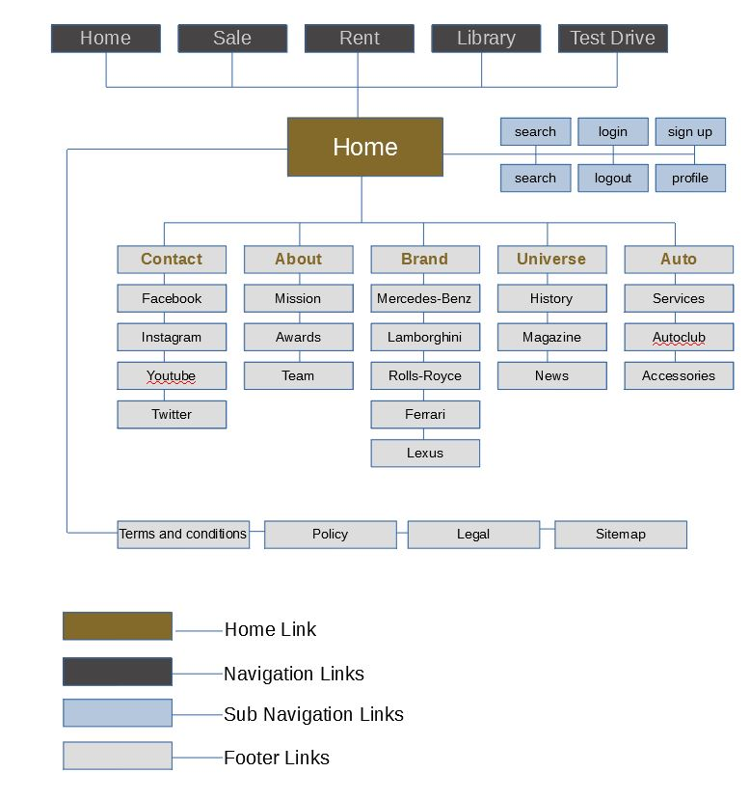

# Preliminary Sitemap Admin Website

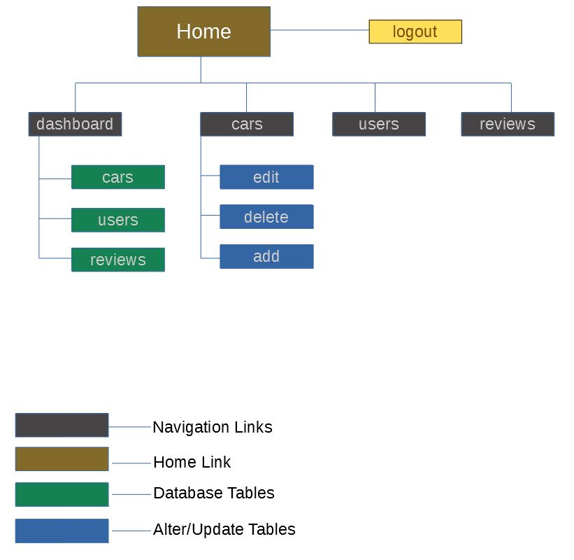

# Wire Frames

**Website “Home” Page**

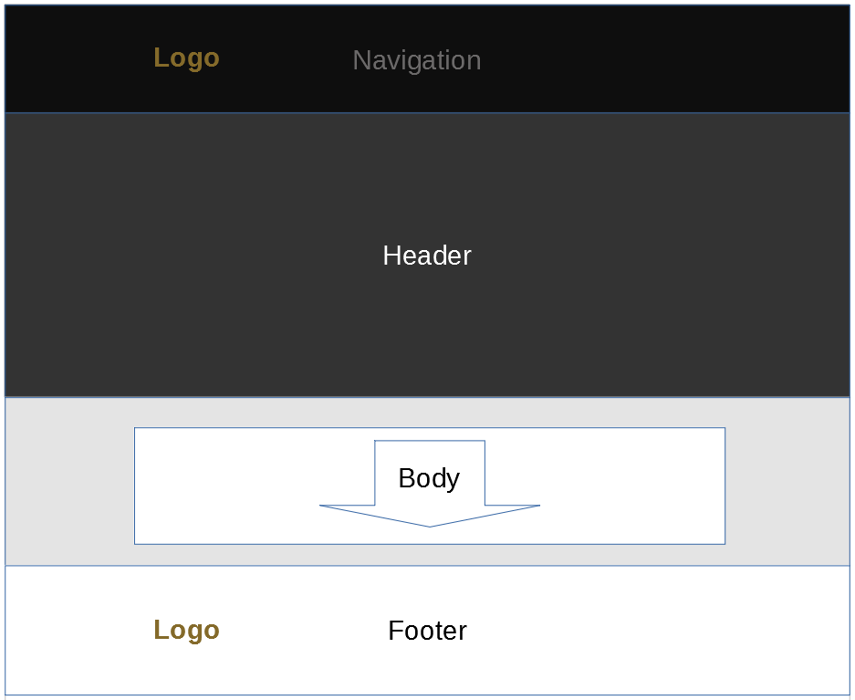

This page is a main page of the website (home). User will open this page by default when browsing the company online. Links to all other web pages can be found on this page. A background image is displayed full screen in order to attract and engage a user. Brief summary of the company’s objectives bellow will engage and navigate the user. For his/her convenience, each section will have a link to other main pages as call to action.

**Website “Sale” Page**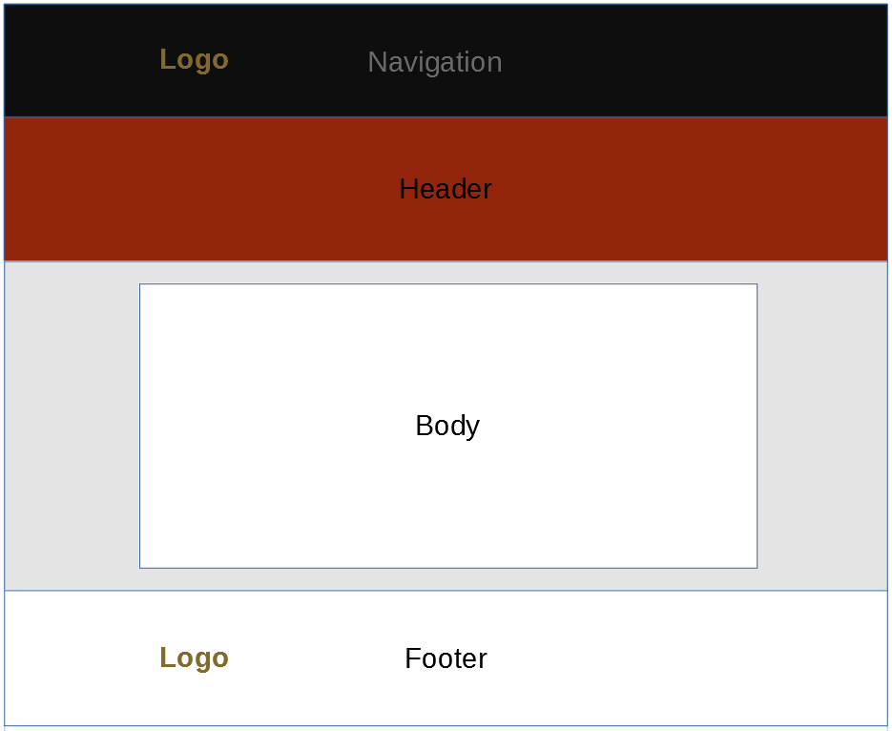

The main purpose of this page is to display exclusive cars for sale. A layout of the page will be similar to the main page. However, a background image will not take the whole page, but will leave a majority of the page for actual content. Each car offer will display an image of the car, a title, a brier description, a price, and a “call to action” for more information about the car. It is expected that this page will be the page where most online deals will be made.

**Website “Rent” Page**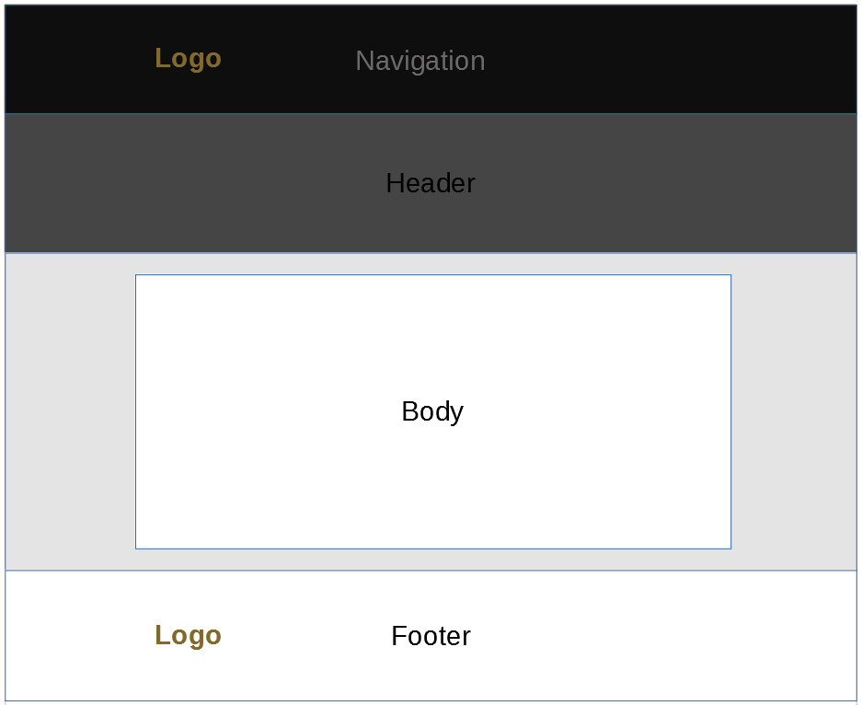

The main purpose of this page is to display exclusive cars for rent. A layout of this page will be similar to previous ones. Each car offer on this page will have an image of the car, a title, a brief description, a price for dayly rent, and “call to action” for learning more about the offer. It is expected that this page will engage secondary audience, young people aged between 18-28, as this age group is known for love to exclusive experience.

**Website “Library” page**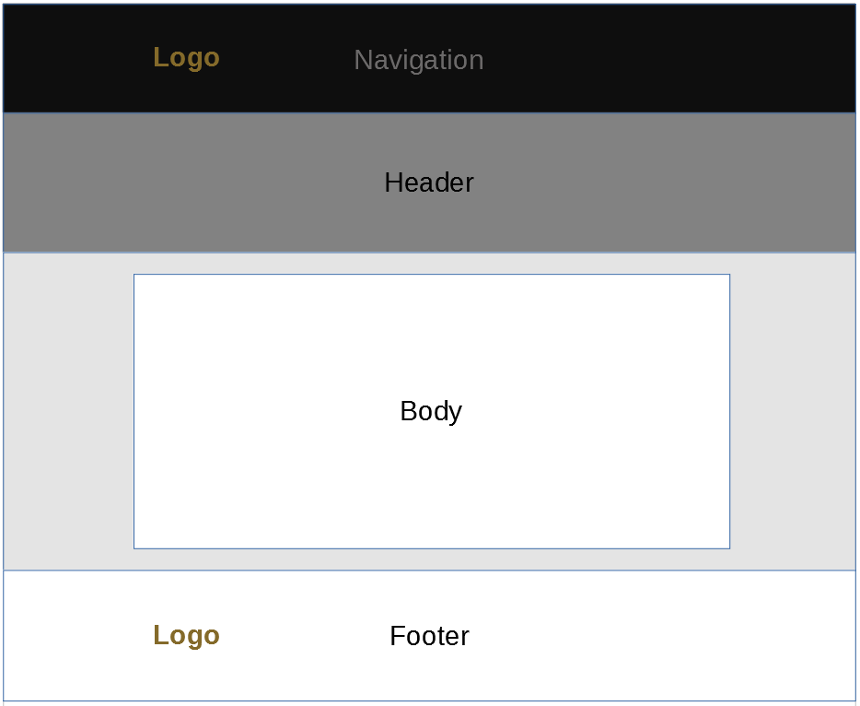

The layout of this page will be similar to other previous pages, except a body of the web page. The body will display a table with major information about all exclusive cars the company has. The main purpose of this page is to gather, compress, and show all the offers. This will be an alternative way of presenting company’s offers, for extra convenience of its clients.

**Website “Test Drive” Page**

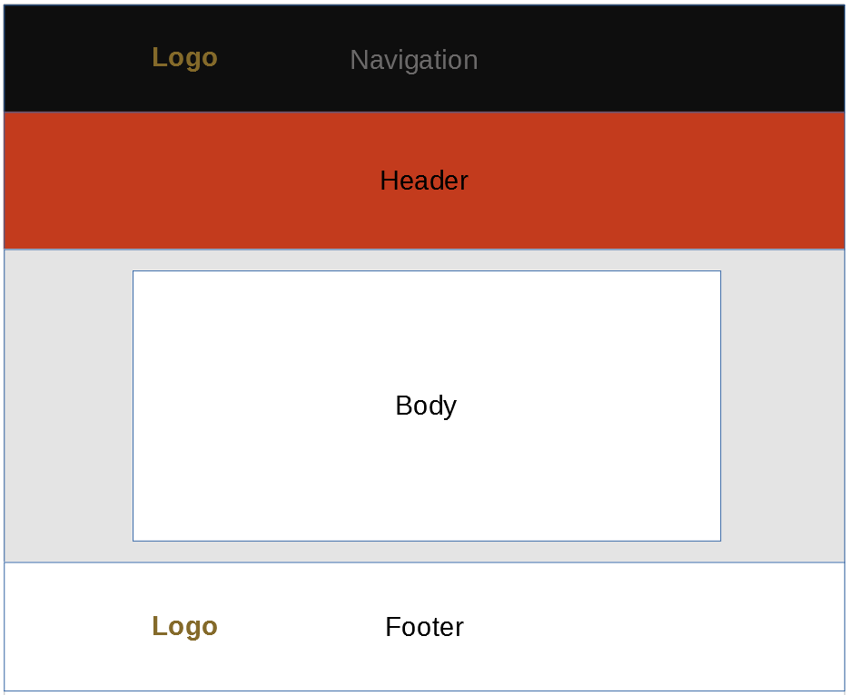

The main purpose of this page is a connection between a potential client and the company. The body of the page will contain a form, which is a request to book an appointment for test drive. The form will gather an information about a potential client and schedule the test drive for a convenient for the client day. All other web pages will have a “call to action” for booking an appointment, which is a link to this page. This page is a final step that a potential client does on the website.

# Design Mock Ups Production Website

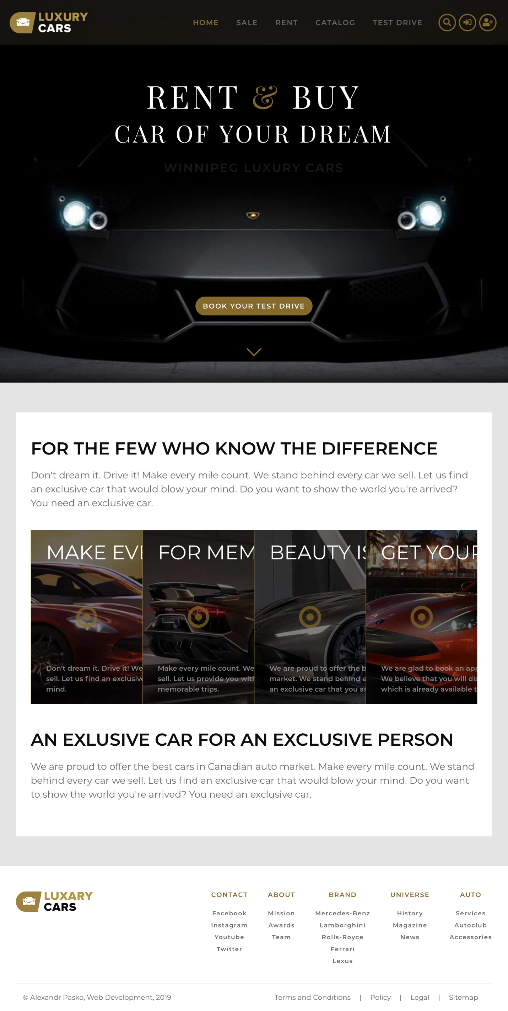

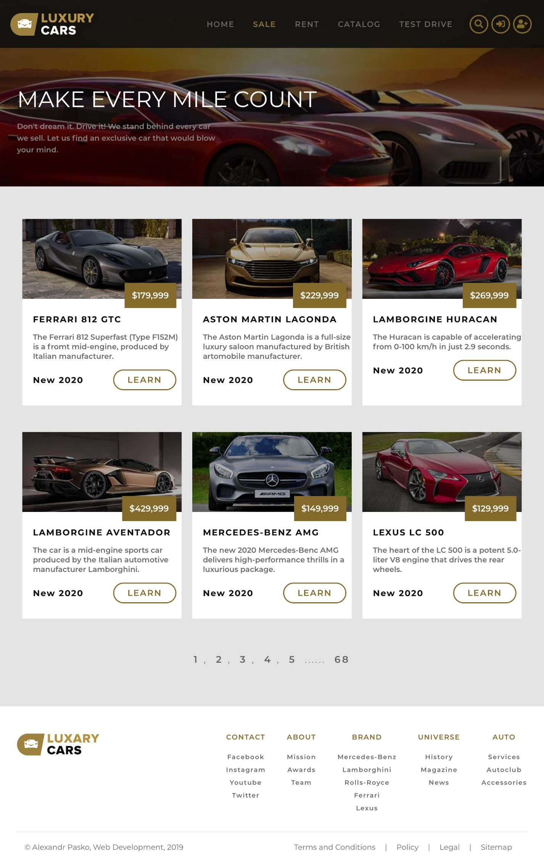

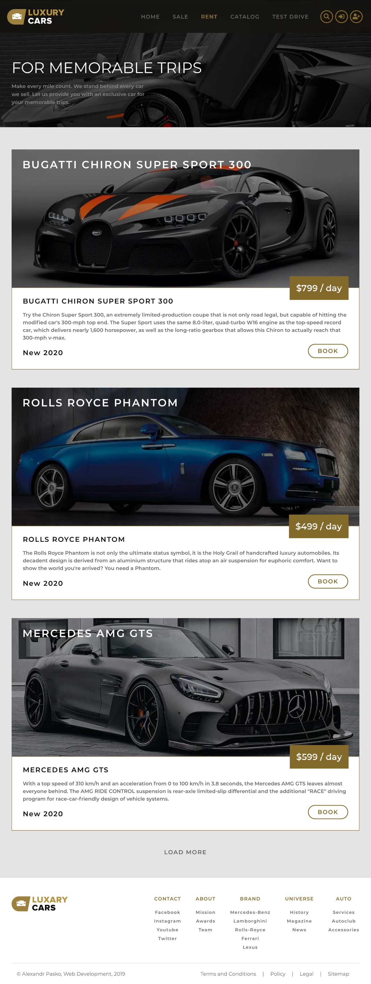

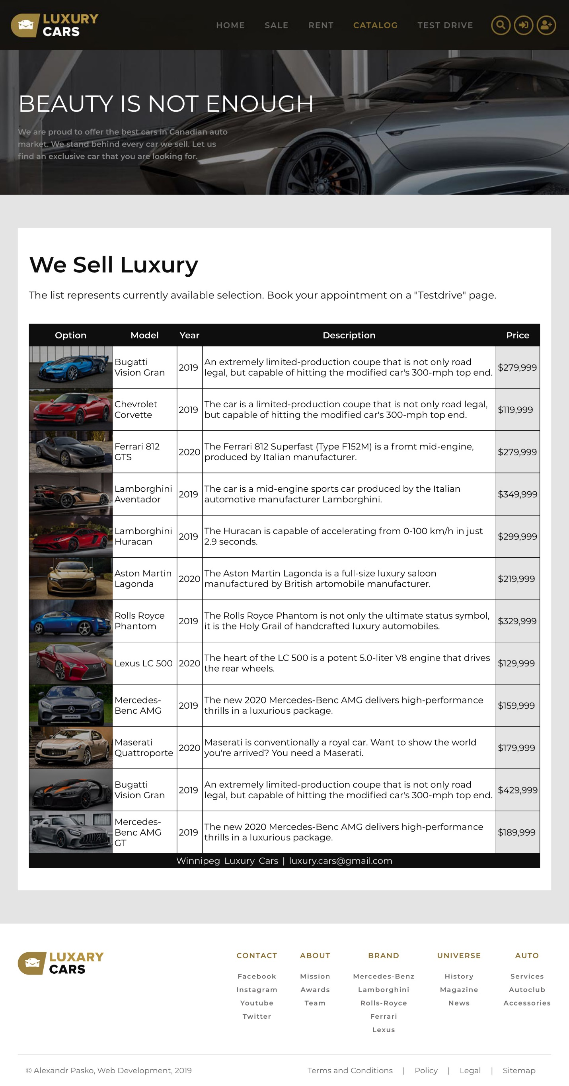

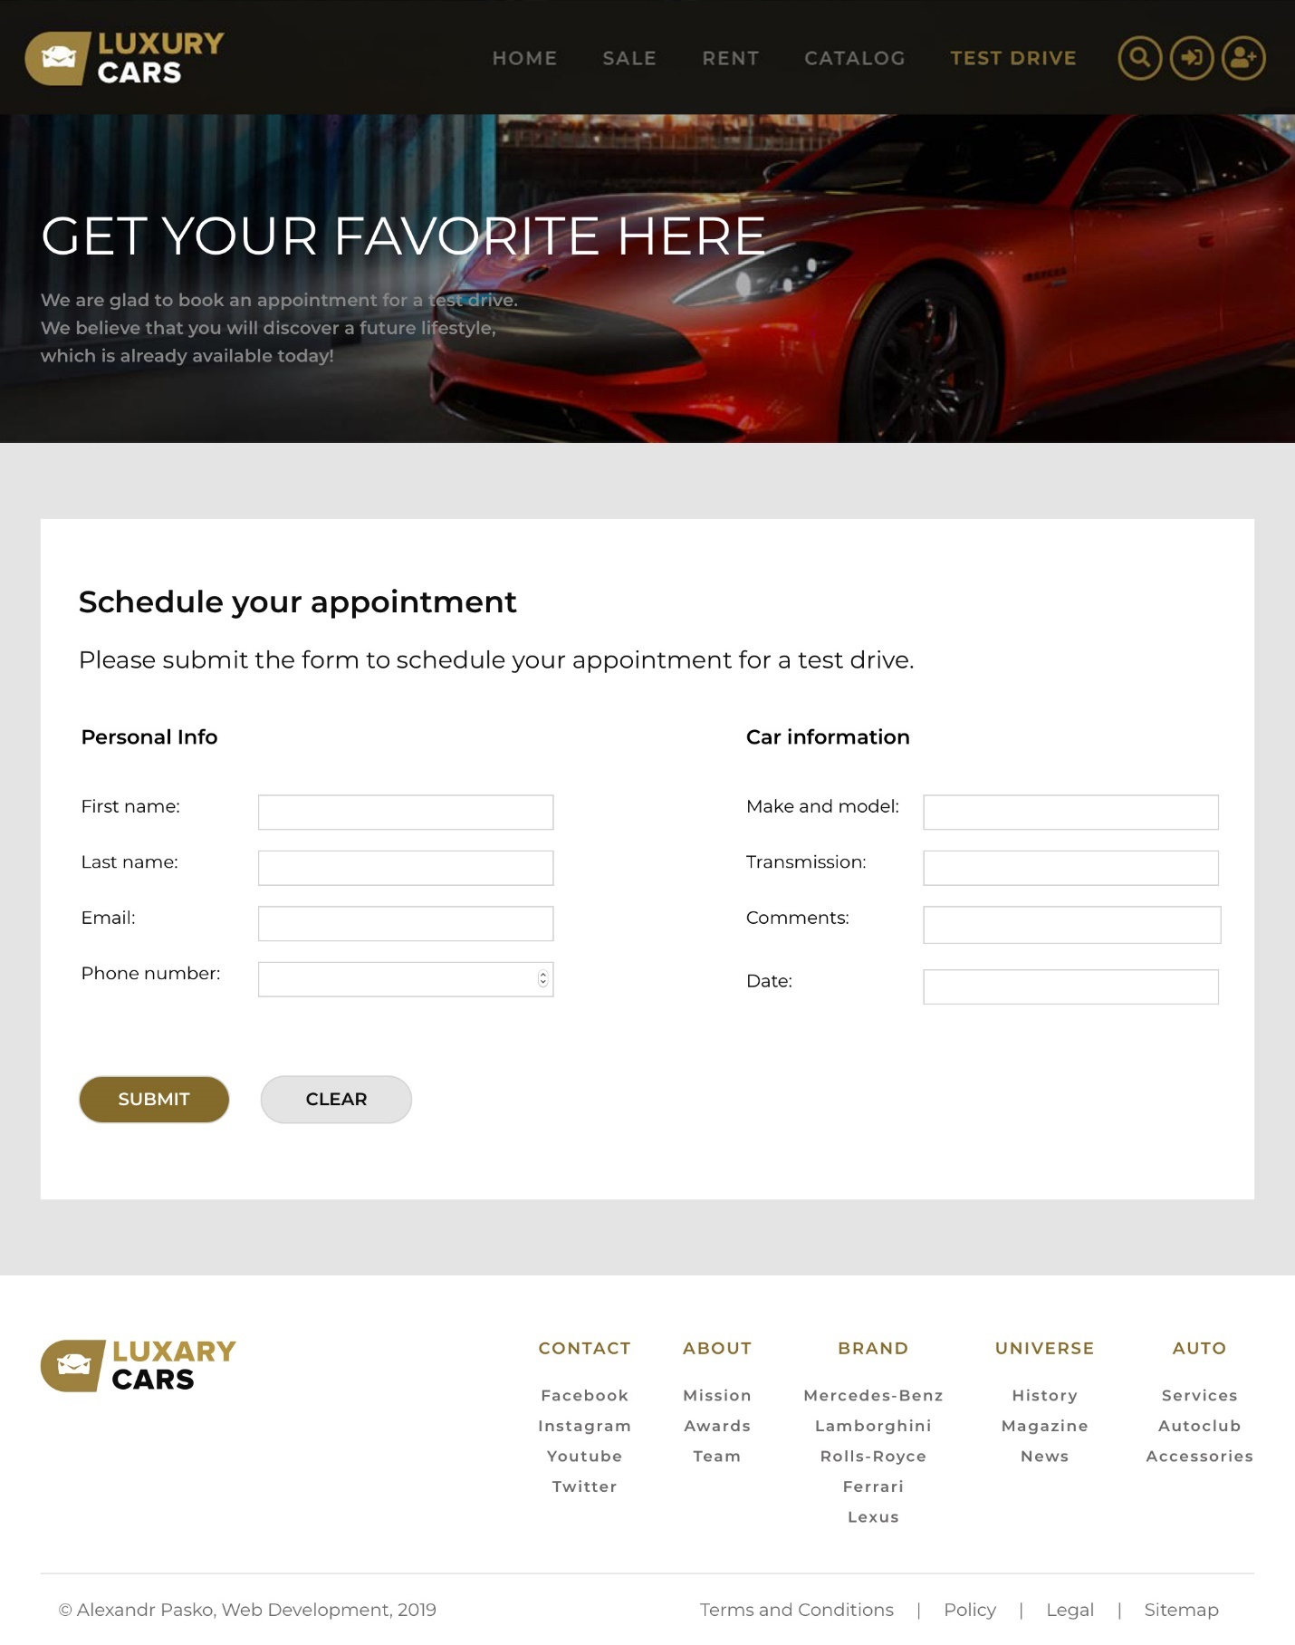

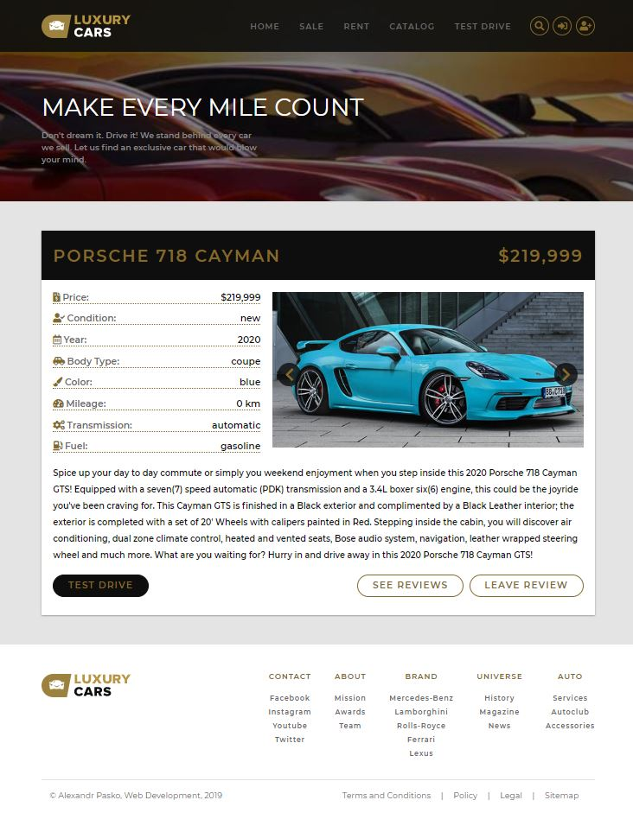

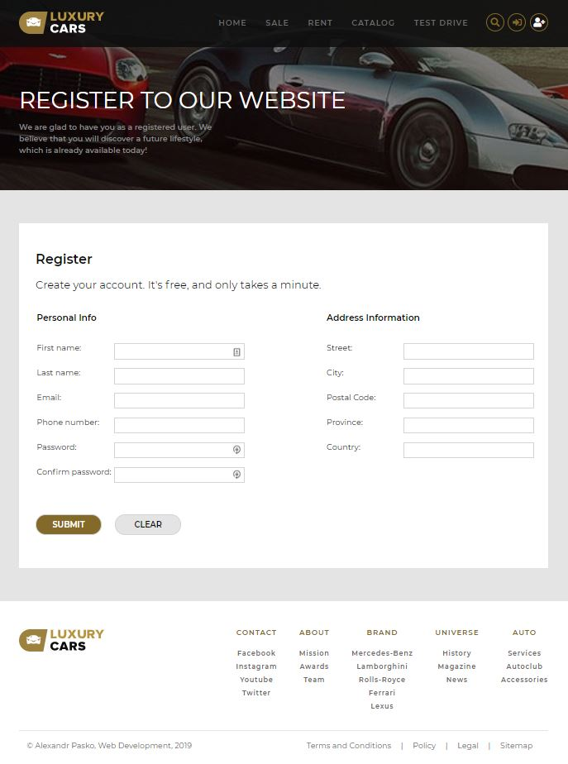

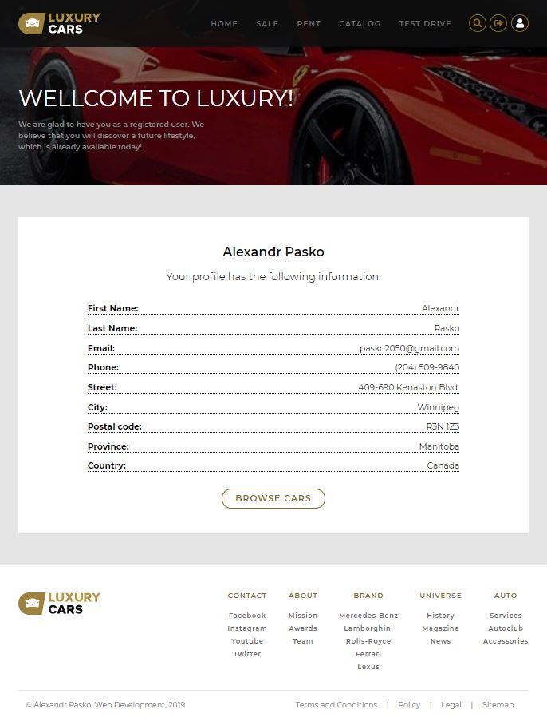

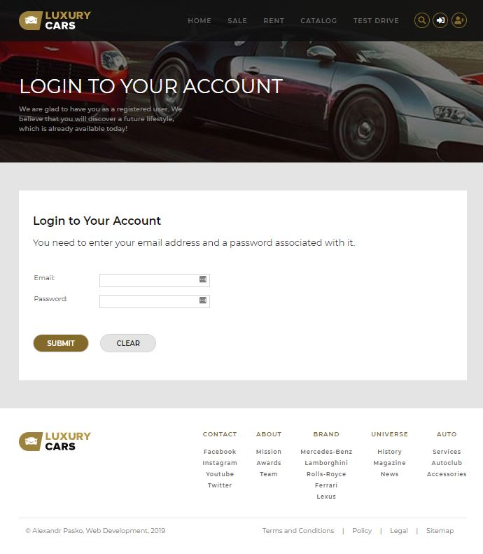

# Design Mock Ups Admin Website

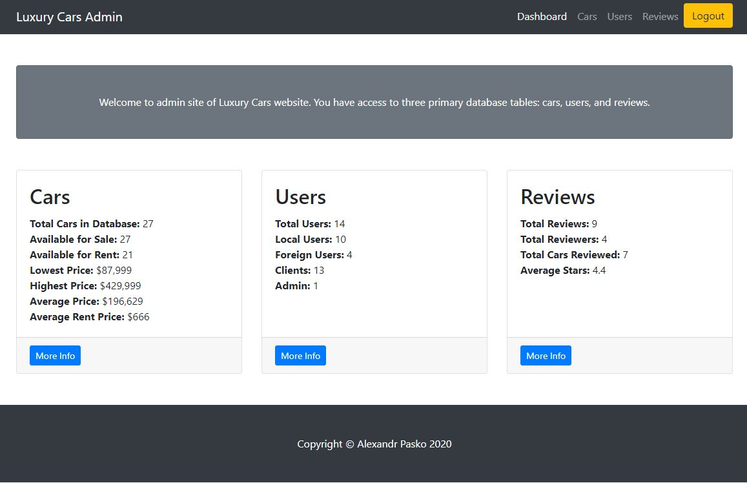

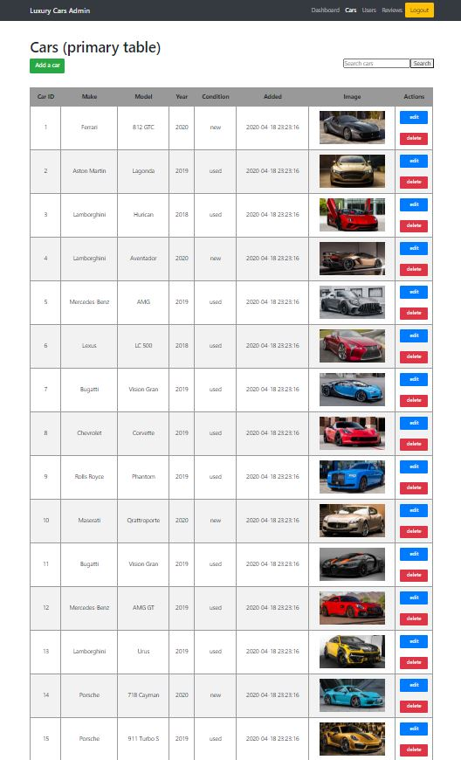

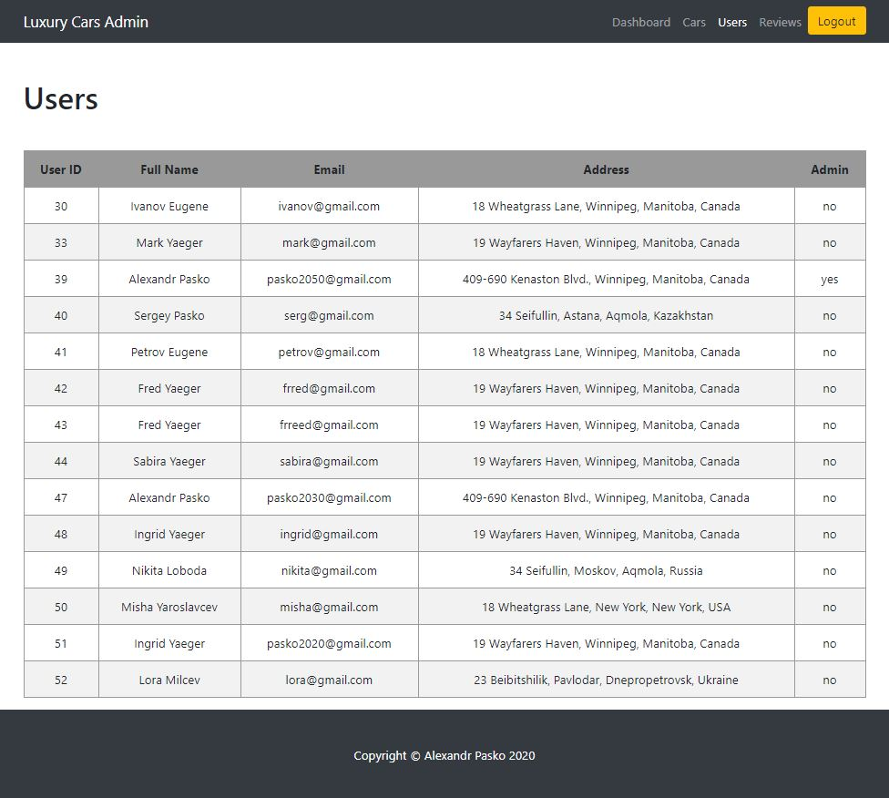

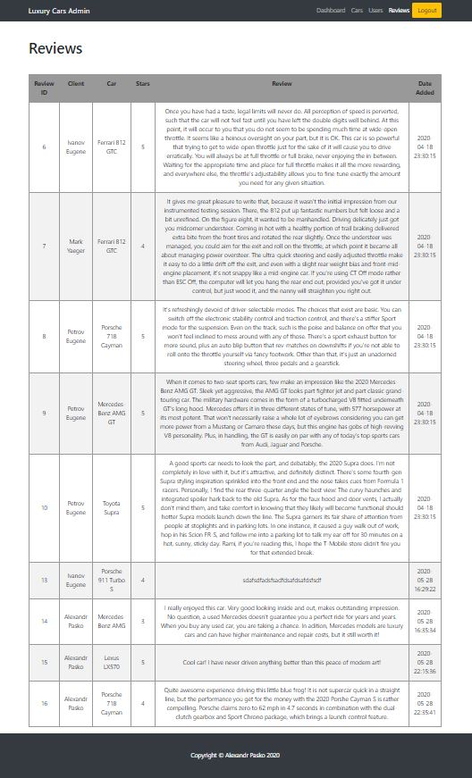

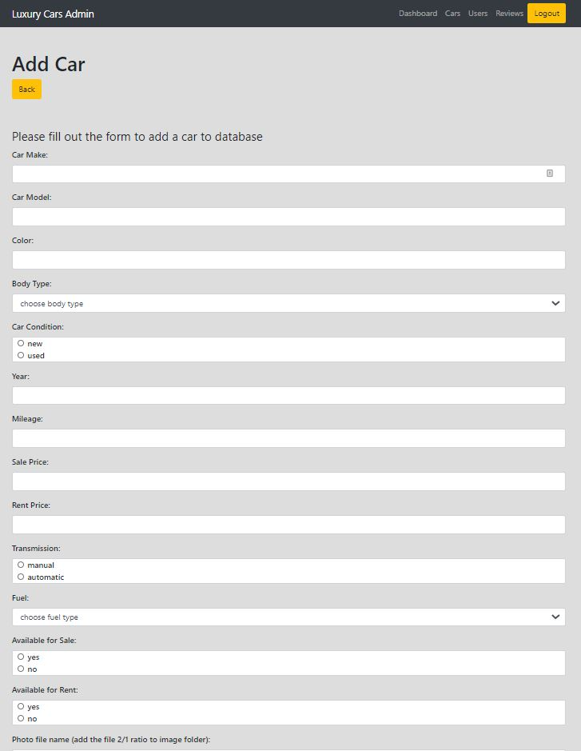

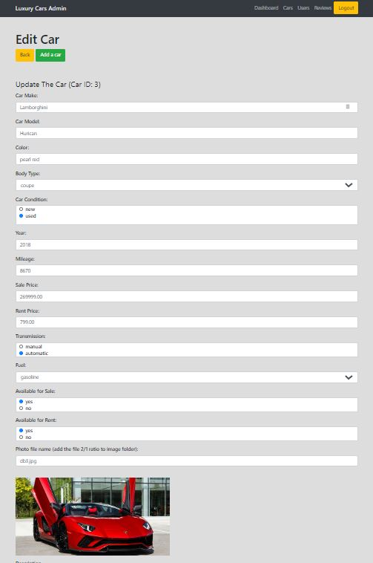

# Conceptual Data Model for Luxury Cars Database

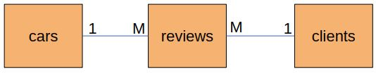

Business rules:

* One car can have many reviews
* One clients can write many reviews
* One review can be about one car and written by one client

# Physical Data Model for Luxury Cars Database

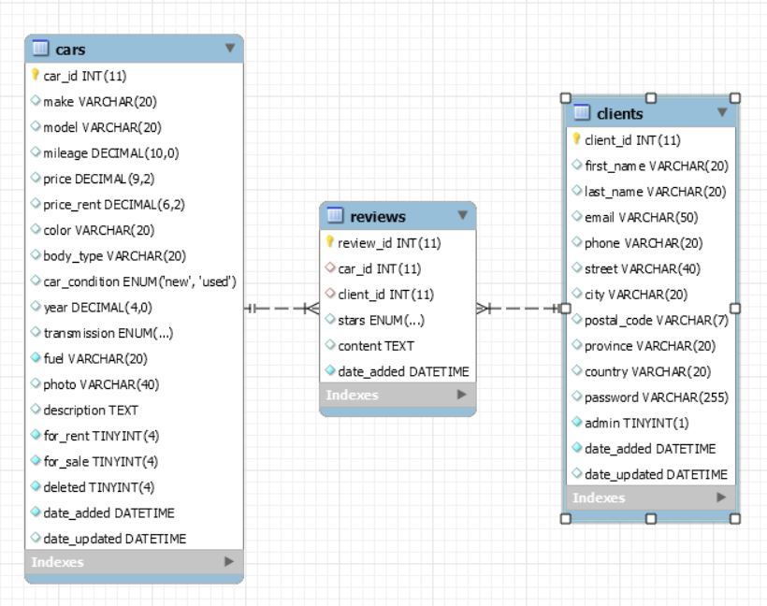

# Invoice

